Table Of Content
  UK-AI Merger Historical Data Migration and Reconfigurations  HR Tech Track for Performance Management | Abstract  This document contains all details regarding historical data migration and reconfigurations  Date: 29 July 2024

1. Revision History 2
2. Team Matrix 2
3. Performance Management Merger Scope 3

- Revision History

Version Number | Date | Changes Made from Previous Version/Remarks
1.0 | 29-July-24

- Team Matrix

- Amit Sood (AI – HR Tech)
- Aparana Gupta (AI – HR Tech)
- Kunal Kansra (AI – HR Tech)
- Suraj Pandey (AI – HR Tech)
- Vikrant Bhatnagar (AI – HR)
- Akanksha Jain (AI – HR)
- Madhurima Bhattacharyya (AI – HR)

- Performance Management System (PMS) Merger Scope
- Currently within AI, PMS is managed using AI SuccessFactors (SF) PMGM module.
- Within Vistara, PMS is managed using UK SF PMGM module.
- End State system aligned for PMS is AI SF PMGM module within the integrated Org since harmonized PMS policies align closely with current AI PMS policies.

Current Design Principles:
Goal Plan Templates:
Air India:
- The Goal Plan template of AI include Goal Plan FY 22-23 & FY 23-24.
- Goal Plan 2024-25 – Field List: Goal Title, Goal Category, Plan of Action, Goal Weightage, KPI [KPI Name*, KPI Weightage*, KPI Target*, Actions], Start Date, End Date and Status.
Vistara:
- The Goal Plan templates of Vistara include Goal Plan FY 21-22, Goal Plan FY 22-23, Goal Plan FY 23-24.
- Goal Plan – Field List: Goal Name, Category, Target, Weightage, Unit of measurement (for e.g. percent, numbers, frequency, time, weight, etc.), Type, Start Date, Due Date, Goal Status, Tasks, Milestones and Audit History.
- Vistara performance forms and performance ratings are available in Vistara instance of SF for past years.

Historical Data Migration:
Goal Template Migration:
- Goal Plan data of past 3 years of Vistara employees will be migrated to AI Goal Plans through mass upload.
- FY 21-22 Goal plan to be created in AI instance for goal data upload as AI Instance does not have FY 21-22 Goal Plan for migration.
- Vistara Goal plan fields to be aligned with AI Goal Plan fields for the migration.
- AI employee codes assigned to Vistara employees will be used for Goal Plan mass upload.
- ‘Copy from previous Goal Plan’ option (feature in SF) to be enabled in AI Instance.
- Goal Plan RBP permissions to be enabled for Vistara employee in AI Instance. Employee, manager and HRBP to have access to this portlet.
- Only active employees Goal Plan to be migrated to AI instance.

AI FY 2024-2025 Goal Plan:
- AI FY 2024-2025 Goal plan launch will be part of harmonized performance review process, 2024-2025 Goal Plan will not be part of mass upload for migration.
Vistara APR Forms Migration:
- Vistara APR Forms will be available only in employee profile as custom MDF portlet on AI Instance; APR forms will not be part of performance module.
- APR forms will be generated in PDF format from Vistara instance and provided for upload in employee profile. Naming convention for PDF files will need to be followed for mapping and upload.
- Custom MDF portlet (performance review forms) to be created in employee profile to upload FY 21-22, FY 22-23, FY 23-24 APR forms.
- Five (5) year’s performance ratings of Vistara employees to be migrated to AI instance in employee profile custom MDF portlet.
- In case data previous to 5 years is required, Anuj, HRSS, Admin access – Copy instance.
- MDF portlet RBP permissions to be enabled for Vistara employee codes in AI Instance.
- Only active employees APR Forms will be part of mass upload for migration.
- For seconded employees who already have an AI employee code, different from current Vistara code, the APR forms will reflect the old Vistara code. Employee communication regarding this to be managed by HR team.

Goal Library Import:
- Goals library will be imported from UK for ensuring bulk goals migration.
- We will download the existing library in CSV, make required changes and then upload with new role titles, rather than migrating directly.
Reconfigurations:
- Following reconfigurations will be done basis harmonization of PMS policies:

- Ground Staff PMS configuration changes:
- Goal Setting FY 2024-25 onwards:
Design Aspect | FY 2023-24 (As-is) | FY 2024-25 (To-Be)
Validations | Performance Goals - min. 2 max. 7, no restriction on weightage | Min. 3 goals, Max. 7 goals, Min. 10%, Max. 35% weightage for each goal
Goal setting workflow and involved users | -Goal to be set by employee  -Approved by manager (Manager can edit/ delete/ add/ send back for significant changes) | Current workflow + Reviewer & HRBP to have access in the completed stage (UK currently has this configuration, we can refer to their system)
Goal modification | It can be requested offline; PMS admin launches Goal modification form. | Give access to HRBP to launch the form, they will initiate only for valid use cases. Workflow remains same (employee modifies and submit, manager approves)
Standard KRAs | Standard Goals auto assigned to employees in mass roles | Continue with Standard Goals for applicable roles. Assigned goals cannot be edited/ deleted. Only learning goals can be edited and set
Development Plan (Learning Goals Fields) | Learning Goal, Milestones, Purpose, Training Need Category – manual entry, no linkage to LMS | Fields remain the same. Linkage to learning modules to be built.  List of Available trainings to be offline shared by Learning team, built as a drop-down in Goal Setting form in the learning goal section. If we can use succession & Career Development module for this, we will shift to that from next year, basis the understanding that this year it can only be available from Nov earliest.
Visibility of Goals | Employee and Manager | Employee, Manager, Reviewer, HRBP
- Annual Review FY 2024-25 onwards:
Design Aspect | FY 2023-24 (As-is) | FY 2024-25 (To-Be)
Overall Rating by Manager | Overall rating is system-calculated (70% goal avg rating and 30% IMPACCT avg rating), no manual overwrites allowed by manager | Moving to the industry best practice, enable the manual rating field for the overall Performance Rating, so that manager can assign a manual rating. We want to configure the view in a way that he ‘overwrites’ the system calculating rating rather than adding another one.
Superpowers and Growth Areas for Emp & Managers | Mandatory Free text fields "Superpower" (top 2 strengths) and "growth area" (top two areas of improvement) | Superpowers and growth areas to be made dropdowns of competencies instead of open text to make it more specific.
Overall Remark | Only for reviewer - optional | Provide this for Manager as well and make it mandatory. I will provide the text to be written as guideline for the field.

- Cabin Crew PMS configuration changes:
- Part A: Keeping the existing configuration as the base, following are the additions/ changes in the existing Cabin Crew PMS configuration to be done on SuccessFactors:
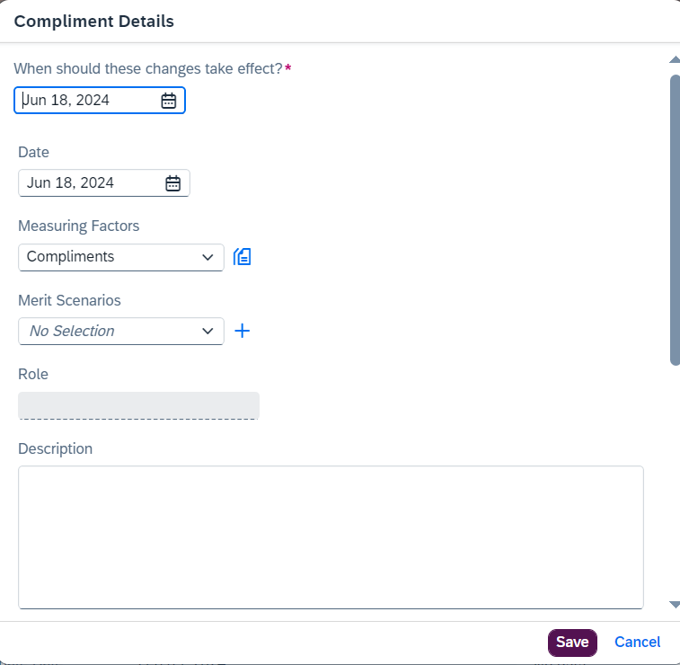
  - There should be just 1 mandatory field called ‘Date’ instead of Effective Date & Date in the current configuration.
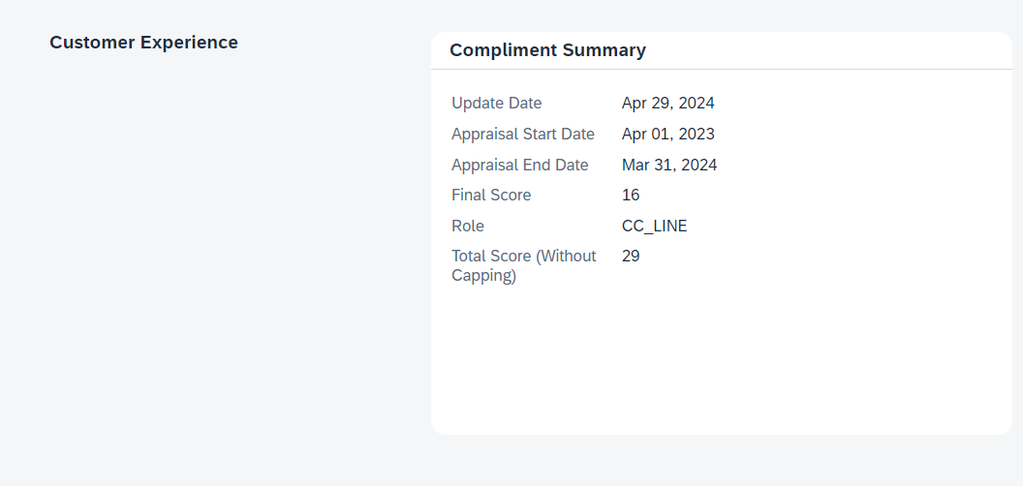
  - The summary section of all portlets will have only one field called as ‘Total Score’ which should be sum of all the Scores in the Details section.
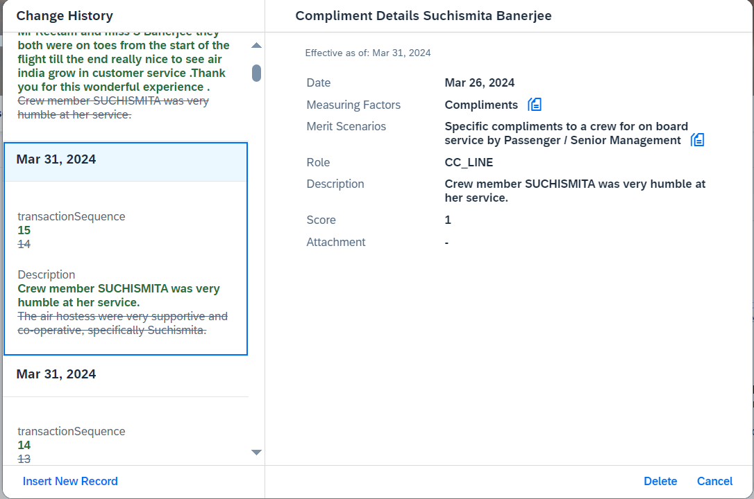
  - Need to remove the feature where a new record appears as if it has replaced the existing (old) record with a strikethrough.
  - Disciplinary letters and Appreciation letters to be triggered automatically.
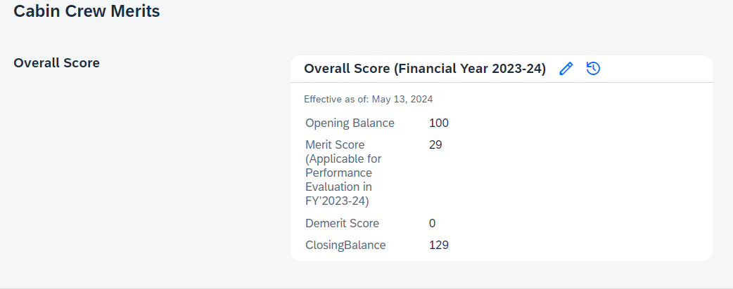
- The portlet of ‘Overall Score’ to have real time integration of relevant ‘Total Scores’ in the respective fields of this portlet. For example - The field of ‘Demerit Score’ should just pick up only the ‘Total Score’ from the Demerits portlet.

- In each portlet, all fields except ‘Description’ to be made mandatory.

- Uploader Name, Upload Date & Upload Time to reflect for each record being added in the Crew’s profile.

- Emails should be triggered because of data updated on Merit or Demerit profiles – template to be shared by HR.

- Part B: Layout – New tabs to be created, and earlier ones reorganized.

  - Section 1: A section called ‘Cabin Crew Performance’ to be created in SuccessFactors. It will have 3 sub-sections – ‘Cabin Crew Merit’, ‘Cabin Crew Demerit’, ‘Overall Performance Feedback’.
  - Section 2: A section called ‘Training’ to be created. (Access to update data in this table should be with Training Admin):
Field | Sub-Field | Sub-Field Type | Variable | Variable Type
Conversion | Option 1: Competent | Multi-Select | General Remarks | Long Text
Conversion | Option 2: Non-Competent | Multi-Select | Professional Knowledge | Long Text
Conversion |  |  | Professional Image | Long Text
Conversion |  |  | Interaction with Guests | Long Text
Conversion |  |  | Interaction with Colleagues | Long Text
Conversion |  |  | Style & Image | Long Text
Conversion |  |  | Voice & Accent | Long Text
Conversion |  |  | Additional Remarks | Long Text
Leadership  (Only for CEs) | Option 1: Competent | Multi-Select | General Remarks | Long Text
Leadership  (Only for CEs) | Option 2: Non-Competent | Multi-Select | Accountable | Long Text
Leadership  (Only for CEs) |  |  | Customer Centric | Long Text
Leadership  (Only for CEs) |  |  | Performance Oriented | Long Text
Leadership  (Only for CEs) |  |  | Additional Remarks | Long Text
Leadership  (Only for CMs) | Option 1: Competent | Multi-Select | General Remarks | Long Text
Leadership  (Only for CMs) | Option 2: Non-Competent | Multi-Select | Accountable | Long Text
Leadership  (Only for CMs) |  |  | Customer Centric | Long Text
Leadership  (Only for CMs) |  |  | Performance Oriented | Long Text
Leadership  (Only for CMs) |  |  | Additional Remarks | Long Text
Service Recurrent | Option 1: Competent | Multi-Select | General Remarks | Long Text
Service Recurrent | Option 2: Non-Competent | Multi-Select | Professional Knowledge | Long Text
Service Recurrent |  |  | Professional Image | Long Text
Service Recurrent |  |  | Interaction with Guests | Long Text
Service Recurrent |  |  | Interaction with Colleagues | Long Text
Service Recurrent |  |  | Style & Image | Long Text
Service Recurrent |  |  | Voice & Accent | Long Text
Service Recurrent |  |  | Additional Remarks | Long Text
Premier Cabin | Option 1: Competent | Multi-Select | General Remarks | Long Text
Premier Cabin | Option 2: Non-Competent | Multi-Select | Professional Knowledge | Long Text
Premier Cabin |  |  | Professional Image | Long Text
Premier Cabin |  |  | Interaction with Guests | Long Text
Premier Cabin |  |  | Interaction with Colleagues | Long Text
Premier Cabin |  |  | Style & Image | Long Text
Premier Cabin |  |  | Voice & Accent | Long Text
Premier Cabin |  |  | Additional Remarks | Long Text

  - Section 3: A section called ‘Cabin Crew Profile’ to be created. Following will be the sub-sections:
  - Sub-section 1: Grooming Card
Field | Sub-Field | Sub-Field Type
Permitted Hairstyle | Remarks | Long Text
Permitted Eye Make Up | Remarks | Long Text
Permitted Lip Shade | Remarks | Long Text

  - Sub-section 2: BMI (one numerical value along with latest date of update)
  - Sub-section 3: Leaders’ Board
  - Additionally, a Leader’s Board to be created as per the following details after the Cabin Crew Merit configuration (Only for CEs). These numbers will be the no. of compliments or complaints received by the CE or all other crew in a flight led by the CE, or generic ones received on the flight.
Portlet Name: Leader’s Board
Fields | Options in Drop Down (if applicable) | Type
Quarter | Q1, Q2, Q3, Q4 | List
No. of Compliments |  | Numeric
No. of Complaints |  | Numeric

Dependencies, Pre-requisites, Assumptions
- Dependencies:
S.No. | Subject
1. | Seconded employees on AI instance who already have a different employee code, the same employee code needs to be used for Goal Template migration.
2. | Vistara Goal Plan fields alignment with AI Goal plan fields.
3. | APR forms of Vistara employees to be available in PDF format.
4. | PDF document size not to be exceeded by 5MB.
5. | PDF will be uploaded in employee profile and may lead to profile page performance issues.

